.
Topic as per syllabus | As per Text Book
Synchronization: Background, Critical Section Problem, Mutex locks,  Semaphores, Classic Problems of Synchronization | Chapter 5 Process Synchronization  5.1 Background  5.2 The Critical-Section Problem  5.5 Mutex Locks  5.6 Semaphores  5.7 Classic Problems of Synchronization
Deadlocks: System Model, Deadlock characterization, Methods for handling  deadlocks, Deadlock prevention, Deadlock avoidance, Deadlock Detection  and Recovery from deadlock | Chapter 7 Deadlocks  7.1 System Model 315  7.2 Deadlock Characterization 317  7.3 Methods for Handling Deadlocks 322  7.4 Deadlock Prevention 323  7.5 Deadlock Avoidance 327  7.6 Deadlock Detection 333  7.7 Recovery from Deadlock 337
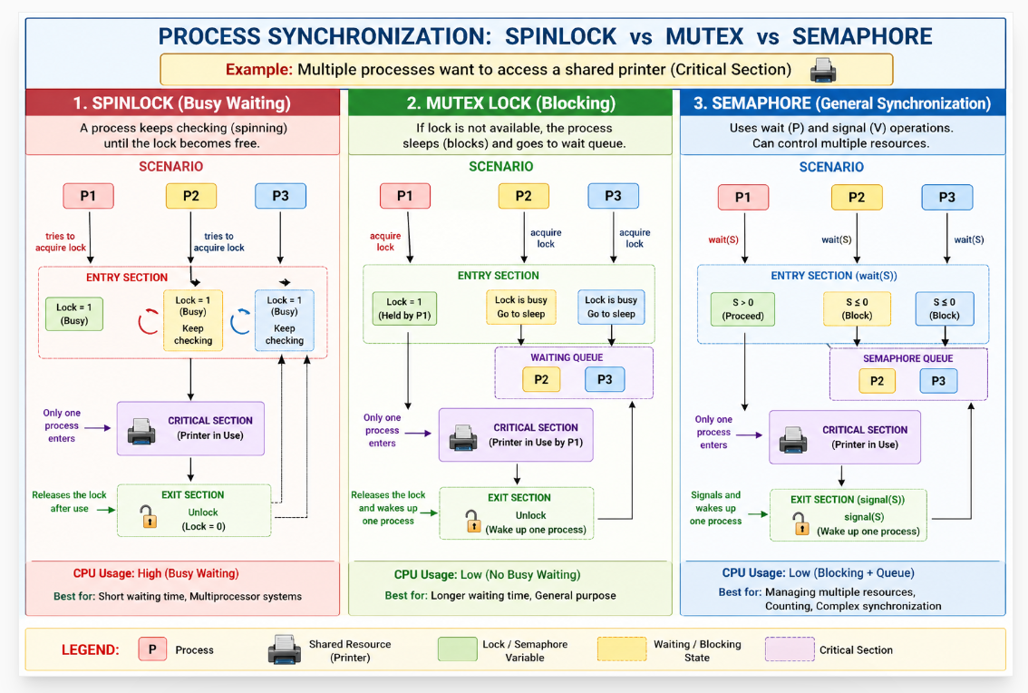

5.7 Classic Problems of Synchronization
Classical synchronization problems occur due to concurrent execution of multiple processes sharing common resources. This leads to race conditions and inconsistent results, making synchronization necessary to ensure correct and orderly execution.
Synchronization problems are solved using mechanisms such as mutex locks, semaphores, and monitors, which enforce mutual exclusion, proper process coordination, and efficient resource usage while avoiding deadlocks and starvation.

5.7.1 The Bounded-Buffer Problem
5.7.2 The Readers–Writers Problem
5.7.3 The Dining-Philosophers Problem
Problem | Introduction
Bounded-Buffer (Producer–Consumer) | Involves a producer generating data and a consumer using it. Both share a fixed-size buffer. The producer must not add items when the buffer is full. The consumer must not remove items when the buffer is empty.
Readers–Writers | Involves multiple readers and writers accessing shared data. Readers can read simultaneously, but writers need exclusive access. No reading is allowed while writing occurs. The challenge is to ensure fairness and avoid starvation.
Dining-Philosophers | Models philosophers sitting around a table sharing forks. Each philosopher needs two forks to eat. Improper allocation can lead to deadlock. The goal is to avoid deadlock and starvation.

5.7.1 The Bounded-Buffer Problem
The bounded-buffer problem involves a shared buffer pool with limited capacity. Semaphores are used to manage synchronization between the producer and consumer processes. The mutex semaphore ensures mutual exclusion, while empty and full semaphores track available and used buffers. The producer adds items to the buffer, and the consumer removes them, with both processes ensuring proper synchronization to prevent race conditions. For example, the producer waits for an empty slot (empty), then accesses the buffer (mutex), and signals the consumer once an item is produced
Producer → empty ↓ , full ↑
Consumer → empty ↑ , full ↓
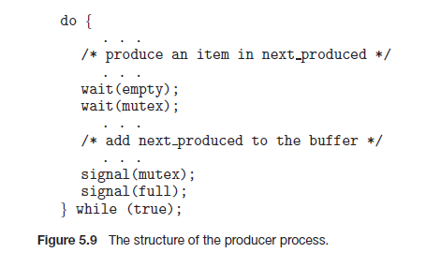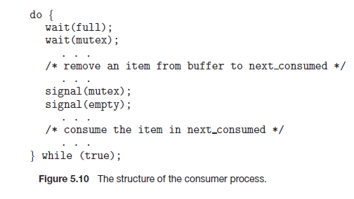

Step | empty | full | mutex | Action | Explanation
Start | 3 | 0 | 1 | Initial | All buffers empty, mutex free
Produce 1 | 2 | 1 | 1 → 0 → 1 | wait(empty), wait(mutex), add item, signal(mutex), signal(full) | Producer enters CS safely, adds item
Produce 2 | 1 | 2 | 1 → 0 → 1 | Same steps | Another item added
Consumer 1 | 2 | 1 | 1 → 0 → 1 | wait(full), wait(mutex), remove item, signal(mutex), signal(empty) | Consumer removes item safely

wait(mutex) → mutex = 0 (lock acquired 🔒)
signal(mutex)→ mutex = 1 (lock released 🔓)
Step | Producer Process | Consumer Process
1 | wait(empty) → check space available | wait(full) → check item available
2 | wait(mutex) → enter critical section | wait(mutex) → enter critical section
3 | ADD ITEM → modify buffer | REMOVE ITEM → modify buffer
4 | signal(mutex) → leave critical section | signal(mutex) → leave critical section
5 | signal(full) → inform consumer | signal(empty) → inform producer

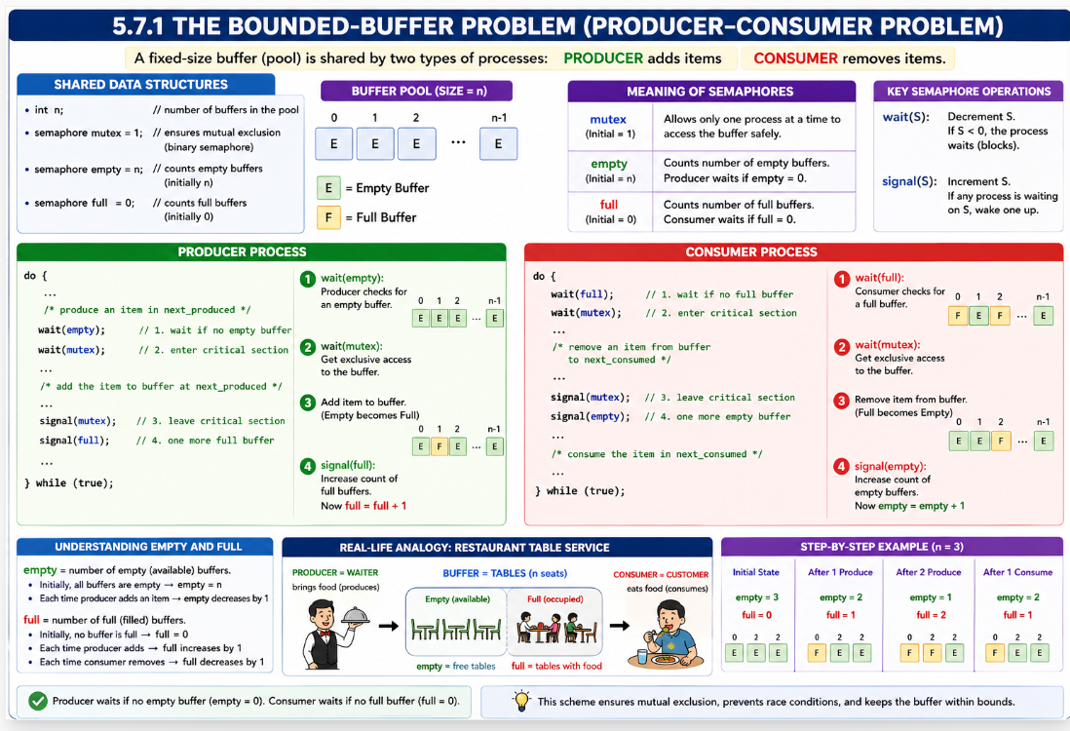

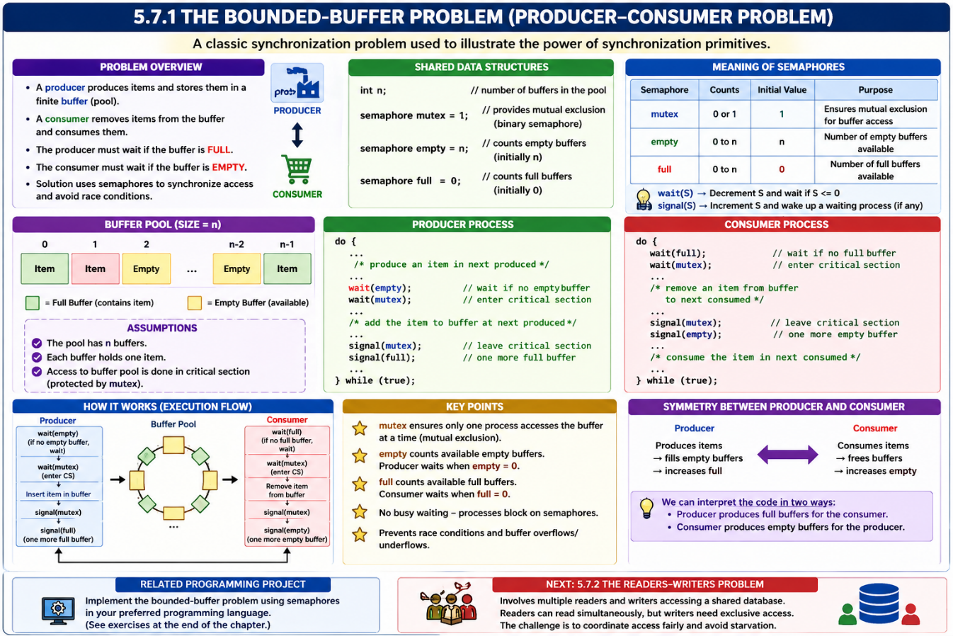

5.7.2 The Readers–Writers Problem
The readers-writers problem involves synchronizing processes that either read from or write to a shared database. Readers can access the database simultaneously, but writers need exclusive access. The problem has variations, including the first and second readers-writers problems. In the first, readers wait only if a writer is active, while in the second, writers should get immediate access when ready. To solve this, semaphores like mutex and wrt manage access to shared resources. The readcount variable tracks active readers, and wrt ensures mutual exclusion for writers. This problem is commonly used to test synchronization techniques, especially in systems with more readers than writers.
The readers–writers problem ensures that multiple readers can access shared data simultaneously, while writers require exclusive access. Different solutions prioritize either readers or writers, which may lead to starvation.
The readers–writers problem has two main variations: reader-priority, where readers are favored and writers may starve, and writer-priority, where writers are favored and readers may starve.”
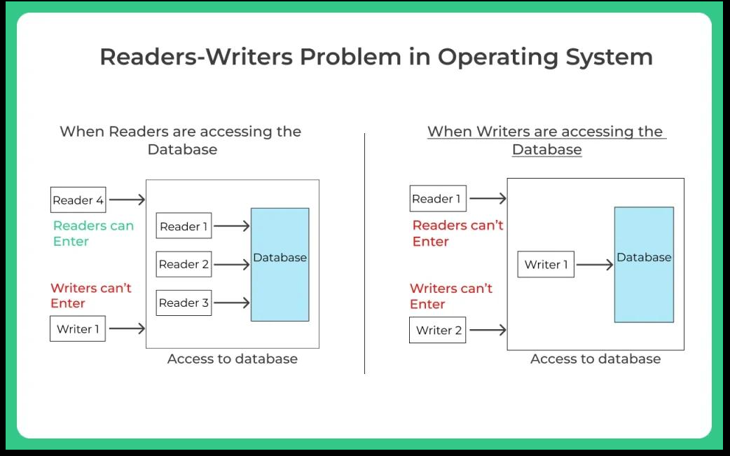
In reader-priority, multiple readers can enter freely causing writer starvation, while in writer-priority, writers are given preference by blocking new readers, which may lead to reader starvation.
In writer-priority solutions, only one writer can access the shared resource at a time, ensuring exclusive access. Other writers and readers must wait until the current writer completes execution.
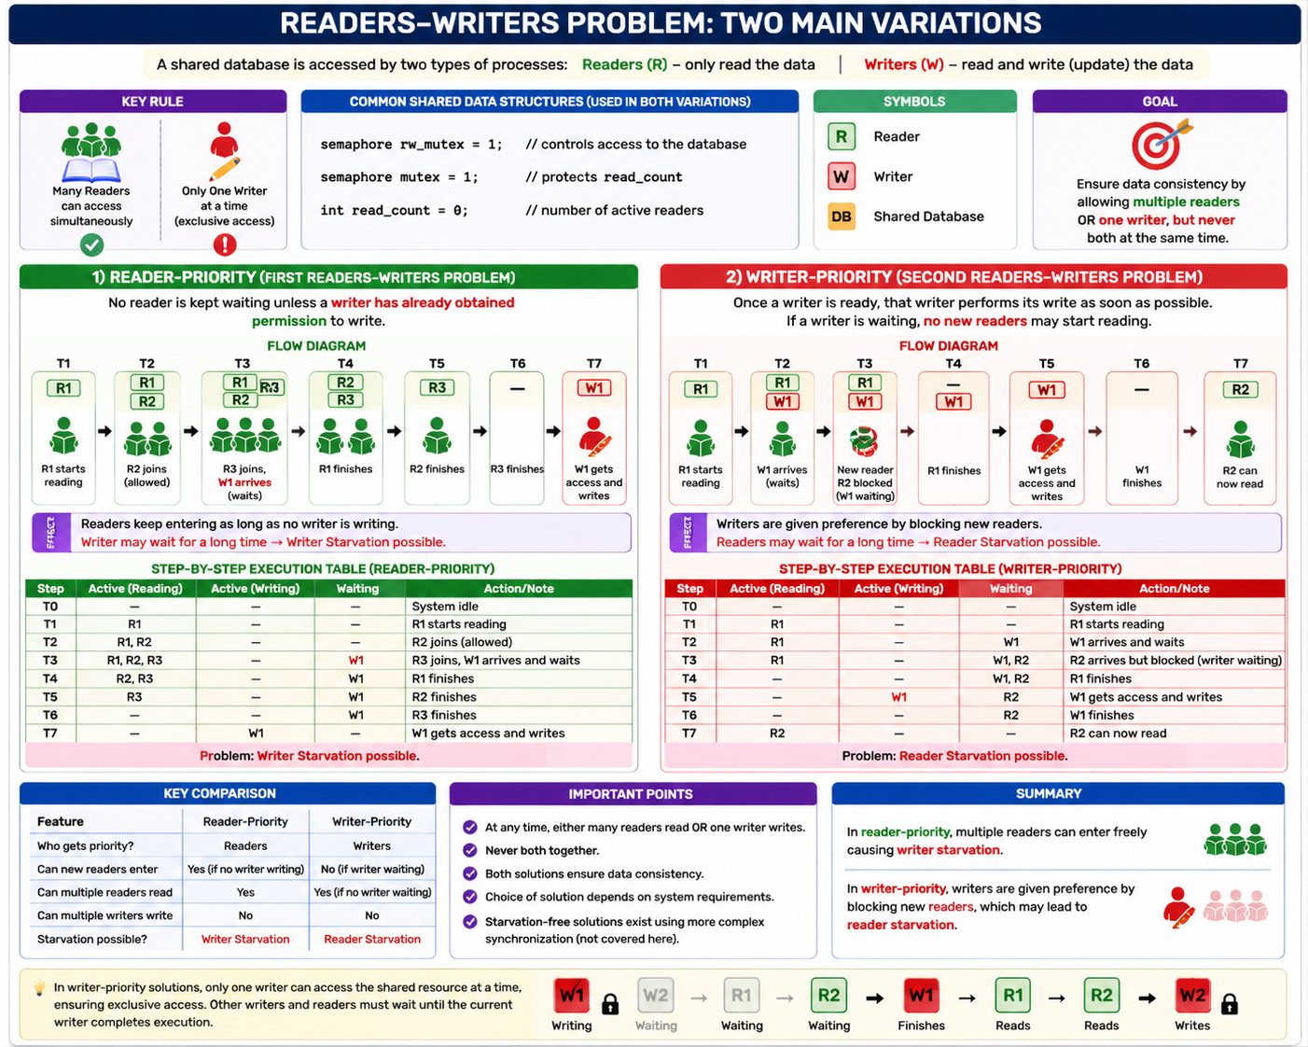

Solution to the first readers–writers problem.
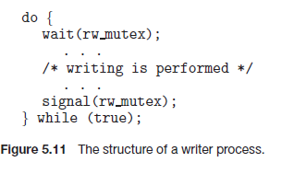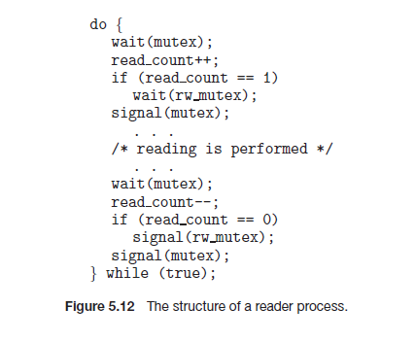
Concept | Purpose | Why Needed | Key Behavior / Explanation | Code Usage
mutex | Protect read_count | Multiple readers may update read_count at same time → race condition ❌ | Only ONE reader can update read_count at a time | wait(mutex); read_count++; signal(mutex);
rw_mutex | Control access to shared database | Prevent reader–writer conflict | ✔ Many readers OR ✔ One writer ❌ Not both | Used by both readers & writers
read_count | Track number of active readers | Needed to know first and last reader | First reader locks rw_mutex; last reader releases it | read_count = number of readers

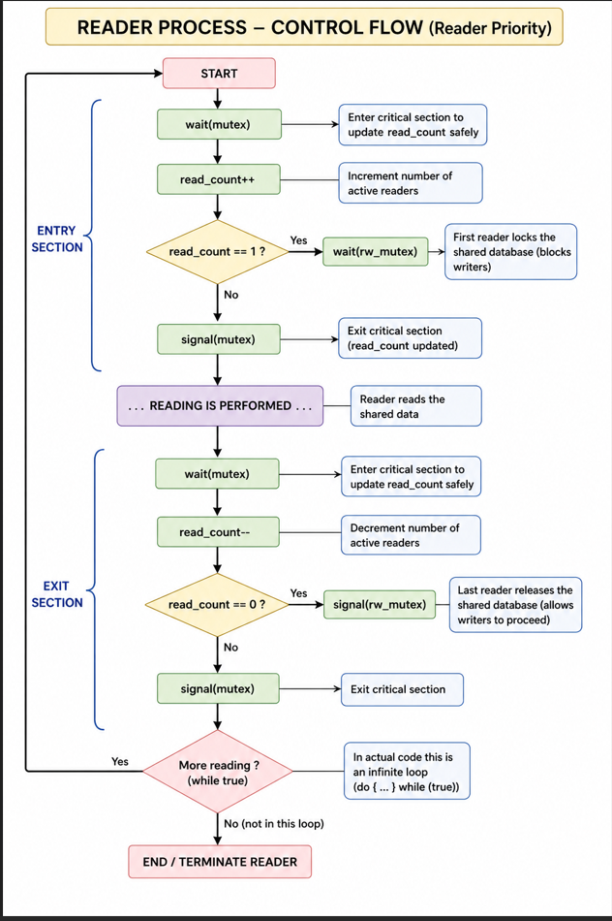

5.7.3 The Dining-Philosophers Problem
The Dining-Philosophers Problem is a classical synchronization problem involving five philosophers sitting around a circular table with five chopsticks placed between them. Each philosopher alternates between thinking and eating.
To eat, a philosopher must acquire both the left and right chopsticks. A philosopher can pick up only one chopstick at a time, and a chopstick already held by a neighbor cannot be used simultaneously.
When a philosopher gets both chopsticks, she starts eating without releasing them. After finishing, she puts down both chopsticks and returns to thinking.
The problem demonstrates how multiple processes compete for limited resources and highlights issues such as deadlock, starvation, and the need for proper synchronization in operating systems.

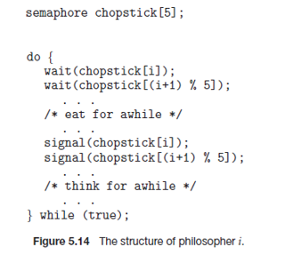

Dining-Philosopher State Transition with Semaphore Operations
A philosopher in the Dining-Philosophers problem can be in one of three states:
State | Meaning
Thinking | Philosopher is idle and not using any fork
Hungry | Philosopher wants to eat and tries to acquire forks
Eating | Philosopher has both forks and is currently eating

When a philosopher becomes hungry, the philosopher executes the wait() operation on the semaphore representing the left fork and then on the right fork.
wait(chopstick[i]); // left fork
wait(chopstick[(i+1)%5]); // right fork
The wait() operation checks the semaphore value:
- If semaphore value = 1 → fork is available
  - semaphore becomes 0
  - philosopher acquires the fork ✅
- If semaphore value = 0 → fork already occupied
  - philosopher is blocked/waits ❌
Thus, a philosopher may hold one fork and wait for the second fork. A philosopher can enter the EATING state only when both forks are successfully acquired.
After completing eating, the philosopher releases both forks using the signal() operation:
signal(chopstick[i]);
signal(chopstick[(i+1)%5]);
The signal() operation changes semaphore value:
0 → 1
meaning:
fork becomes free again
After releasing both forks, the philosopher returns to the THINKING state.

THINKING
↓
HUNGRY
↓
wait(left fork)
wait(right fork)
↓
EATING
↓
signal(left fork)
signal(right fork)
↓
THINKING

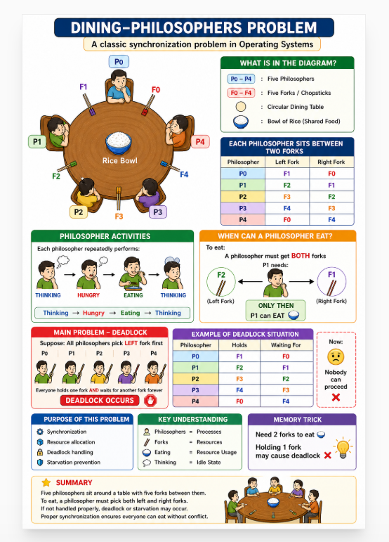

Dining-Philosophers Example (Time-wise Execution)
5 Philosophers → P0, P1, P2, P3, P4
5 Forks → F0, F1, F2, F3, F4
Initially:
Fork | Value
F0 | 1
F1 | 1
F2 | 1
F3 | 1
F4 | 1

1 = FREE
0 = BUSY

wait(chopstick[i]); // left fork
wait(chopstick[(i+1)%5]); // right fork

Philosopher (i) | Left Fork chopstick[i] | Right Fork chopstick[(i+1)%5] | Mod Calculation
P0 | F0 | F1 | (0+1)%5 = 1
P1 | F1 | F2 | (1+1)%5 = 2
P2 | F2 | F3 | (2+1)%5 = 3
P3 | F3 | F4 | (3+1)%5 = 4
P4 | F4 | F0 | (4+1)%5 = 0

Case1

Time | Philosopher Action | Fork Status | Result
T0 | All philosophers THINKING | F0=1 F1=1 F2=1 F3=1 F4=1 | All forks free
T1 | P0 executes wait(F0) | F0=0 | P0 gets left fork
T2 | P1 executes wait(F1) | F1=0 | P1 gets left fork
T3 | P2 executes wait(F2) | F2=0 | P2 gets left fork
T4 | P3 executes wait(F3) | F3=0 | P3 gets left fork
T5 | P4 executes wait(F4) | F4=0 | P4 gets left fork
T6 | P0 tries wait(F1) | F1 already busy | P0 BLOCKED
T7 | P1 tries wait(F2) | F2 already busy | P1 BLOCKED
T8 | P2 tries wait(F3) | F3 already busy | P2 BLOCKED
T9 | P3 tries wait(F4) | F4 already busy | P3 BLOCKED
T10 | P4 tries wait(F0) | F0 already busy | P4 BLOCKED

Case 2

Time | Active Philosopher | Left Fork | Right Fork | wait()/signal() Operation | Fork Status After Execution | Holding / Waiting Status | Result
T0 | All | — | — | Initial State | F0(1) F1(1) F2(1) F3(1) F4(1) | No one holding forks | All forks free
T1 | P0 | F0 | F1 | wait(F0), wait(F1) | F0(0) F1(0) F2(1) F3(1) F4(1) | P0 holds F0,F1 | P0 starts EATING
T2 | P1 | F1 | F2 | wait(F1) | F0(0) F1(0) F2(1) F3(1) F4(1) | P1 waiting for F1 | P1 BLOCKED
T3 | P2 | F2 | F3 | wait(F2), wait(F3) | F0(0) F1(0) F2(0) F3(0) F4(1) | P2 holds F2,F3 | P2 starts EATING
T4 | P3 | F3 | F4 | wait(F3) | F0(0) F1(0) F2(0) F3(0) F4(1) | P3 waiting for F3 | P3 BLOCKED
T5 | P4 | F4 | F0 | wait(F4) | F0(0) F1(0) F2(0) F3(0) F4(0) | P4 holds F4 only | P4 got left fork
T6 | P4 | F4 | F0 | wait(F0) | F0(0) F1(0) F2(0) F3(0) F4(0) | P4 waiting for F0 while holding F4 | P4 BLOCKED
T7 | P0 | F0 | F1 | signal(F0), signal(F1) | F0(1) F1(1) F2(0) F3(0) F4(0) | P0 releases all forks | P0 finishes EATING
T8 | P1 | F1 | F2 | wait(F1) | F0(1) F1(0) F2(0) F3(0) F4(0) | P1 holds F1 only | P1 acquired left fork
T9 | P1 | F1 | F2 | wait(F2) | F0(1) F1(0) F2(0) F3(0) F4(0) | P1 waiting for F2 while holding F1 | P1 BLOCKED
T10 | P2 | F2 | F3 | signal(F2), signal(F3) | F0(1) F1(0) F2(1) F3(1) F4(0) | P2 releases all forks | P2 finishes EATING
T11 | P1 | F1 | F2 | wait(F2) | F0(1) F1(0) F2(0) F3(1) F4(0) | P1 now holds F1,F2 | P1 starts EATING
T12 | P3 | F3 | F4 | wait(F3) | F0(1) F1(0) F2(0) F3(0) F4(0) | P3 holds F3 only | P3 acquired left fork
T13 | P3 | F3 | F4 | wait(F4) | F0(1) F1(0) F2(0) F3(0) F4(0) | P3 waiting for F4 while holding F3 | P3 BLOCKED
T14 | P1 | F1 | F2 | signal(F1), signal(F2) | F0(1) F1(1) F2(1) F3(0) F4(0) | P1 releases all forks | P1 finishes EATING
T15 | P4 | F4 | F0 | wait(F0) | F0(0) F1(1) F2(1) F3(0) F4(0) | P4 now holds F4,F0 | P4 starts EATING

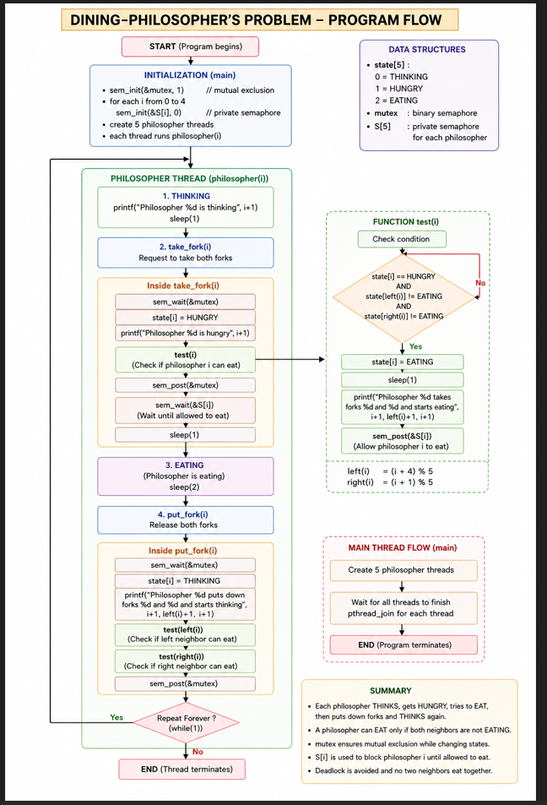
The Dining-Philosophers Problem is a classical process synchronization problem used to explain issues such as deadlock, resource allocation, and concurrency control in operating systems.
The problem consists of five philosophers sitting around a circular table with five chopsticks/forks placed between them. Each philosopher repeatedly performs two activities:
THINKING 🤔
EATING 🍚
While thinking, a philosopher does not need any resource. When a philosopher becomes hungry, the philosopher tries to acquire two forks:
- Left fork → Fi
- Right fork → F(i+1)%5
A philosopher can pick up only one fork at a time. The forks are represented using semaphores.

Deadlock Situation
A deadlock occurs if all philosophers simultaneously pick up their left fork and wait for the right fork.
Example:

Philosopher | Holds | Waiting For
P0 | F0 | F1
P1 | F1 | F2
P2 | F2 | F3
P3 | F3 | F4
P4 | F4 | F0

Deadlock Prevention Methods

🔹 Allow only 4 philosophers at a time
At least one philosopher can always eat.

🔹 Pick both forks together
A philosopher can eat only if both forks are available simultaneously.

🔹 Asymmetric Solution
- Odd philosophers pick left fork first
- Even philosophers pick right fork first
This breaks circular waiting.

